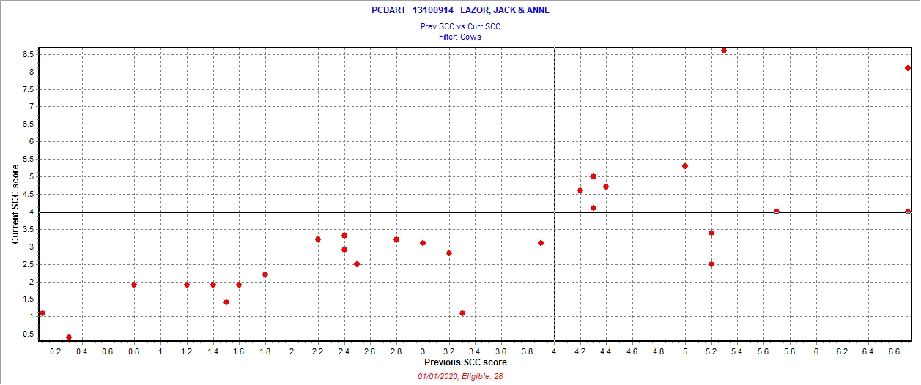December 24 2019 test date

New = 0 =

Chronic = 9 = 32.1%

Cure = 2 = 7.1%

Uninfected = 17 = 60.7%

Also 3 fresh cows SCC > 3.9